Follow the exercises below.

Add a motion path to the image of the earth to make it move from one side of the screen to the other
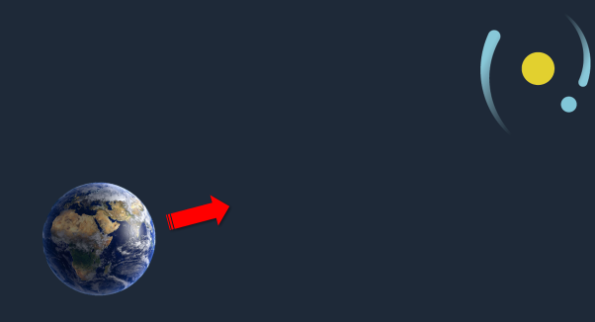
Create a transition between your slides.
